**Two Mirror Trees:-**

Given a Two Binary Trees, write a function that returns true if one is mirror of other, else returns false.  
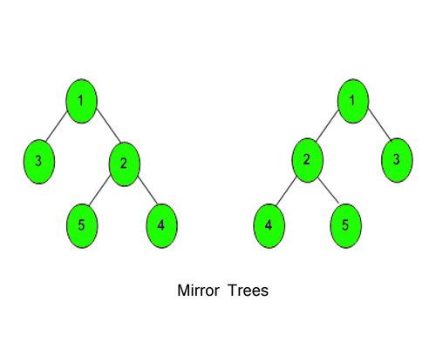

**Example 1:**

**Input:**

**T1:** 1 **T2:** 1

  / \ / \

  2 3 3 2

**Output:** 1

**Example 2:**

**Input:**

**T1:** 10 **T2:** 10

  / \ / \

  20 30 20 30

  / \ / \

  40 60 40 60

**Output:** 0

**Your Task:**  
You don't need to take input. Just complete the function**areMirror()**that takes root **node of two tree**as parameter and returns **true,**if one is the mirror of other else returns **false**. (The driver's code print 1 if the returned value is **true,**otherwise 0)  
**Expected Time Complexity:**O(N).  
**Expected Auxiliary Space:**O(Height of the Tree).  
  
**Constraints:**  
1 <= Number of nodes<= 10000  
-1000 <= Data of a node<= 1000